D&C Quick Reference Guide

FM 3-21.5 --- Army Field Manual for Drill and Ceremonies that we use as a base guide for our movements. We adapt to what works best for our details just as the “Old Guard” does, so not every movement that we do is covered in the FM 3-21.5.

The two parts of calling commands---
Preparatory Command---States the movement to be carried out and gets you ready to do the movement.
Command of Execution---Tells you when to execute the movement.

When marching we always start off with the left foot and take a full 30” step, the arms swing in a natural motion, without exaggeration and without bending at the elbows. The arms swing approximately 9” to the front and 6” to rear of the trouser.

The main purpose for close order drill is to move a large group in an orderly and timely manner. Drill also instills professionalism, teamwork, discipline, confidence and pride.

Position of Attention
  - Back Straight
  - Feet Together (Heels and Toes Touching)
  - Hands Along Trouser Seam
  - Fingers Curled in with Thumbs on the Outside Running Down Seam
  - Head and eyes forward at all time (no movement)
Parade Rest
- Pop Can Width
- Position of Feet and Hands
- Right hand over the left
- Eyes only – no head movement
At Ease
- “Stand at, Ease”
- Same as position of parade rest but arms relaxed
- Head and eyes can move to follow instructor/OIC/Etc
Ceremonial At Ease
- Starts From or Goes To (From Attention) Position of Parade Rest First
- Left Hand Over Right at Belt Buckle
- On Prep Command Go To Parade Rest Before Going Back to Attention
Rest
- Arms can move and all can move except right foot.

Always return to the position of parade rest before going to attention

Present and Order Arms
- Show positioning of Arm and Hand
- 3 Second Count Up and Down

Facing Movements
- Right Face (Normal - Not T-Turns)
- Left Face (Normal - Not T-Turns)
- About Face (Normal - Not T-Turns)

Marching Movements
- Forward March
- 30 inch Step
- Align off person to the right
- Halt
- Column Right (See Diagram on next page for Further)
- Column Left (See Diagram on next page for Further)
- Right Flank
- Left Flank
- Rear March (To The Rear, March)
- Eyes Right
  - Right side looks straight ahead and covers
  - All other squads look 45 Degrees to the Right
  - Only the OIC Salutes

Formational Movements
- Open Ranks
  - 1st Squad Takes 2 steps forward
  - 2nd Squad Takes 1 step forward
  - 3rd Squad Stays Where They Are
  - 4th Squad Takes Two ½ Steps Back
- Close Ranks
  - 1st Squad Takes Four ½ Steps Back
  - 2nd Squad Takes Two ½ Steps Back
  - 3rd Squad Stays Where They Are
  - 4th Squad Takes 1 Step Forward
- Dress Right Dress
  - Normal Interval
  - Close Interval
- Alignment
  - Always to the Right
- Cover
  - Always to the front

Column Movement Diagram: (Column Right)
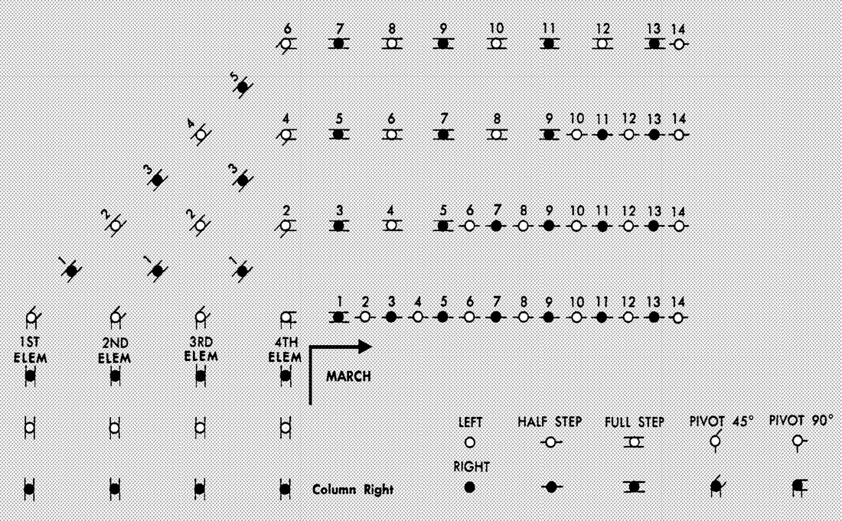

Column Left is just the opposite…

